**LABVIEW BASED GREENHOUSE AUTOMATION SYSTEM THROUGH WIRELESS PROTOCOL**

**ABSTRACT**

Monitoring of the climatic condition is an important part of agricultural cultivation which has an immediate effect on the crop production and its maintenance. For the past few years, greenhouse automation with different strategies, achievement is in a notable height in the climatic control by means of increasing the plant growth and avoiding the seasonal changes on the plants. In order to obtain an optimum environmental condition for plant growth, it is essential to control the environmental conditions based on the crop condition. The environmental parameters such as humidity, temperature, light, soil moisture and CO2 concentration need to be controlled for the proper growth attainment of the plant. In this paper real-time parameter has been measured and serially communicated to the host system by means of ZigBee technology with LabVIEW and microcontroller, for the proper maintenances of climatic conditions according to the plant growth.

**INTRODUCTION**

More than 90% of plants around the world, either food crops or cash crops have been grown in the open field under natural environmental conditions. The continuous change in climatic condition may affect the plant's growth. The greenhouse is the technique of providing a favorable environmental condition to the plants. It is used to increase the growth rate, yield, and quality and also protects the crops/plants from the bad weather situations such as cold/hot current of air, extreme temperature, insects, and diseases. It is also important to create an ideal climate condition around the plants for their proper growth.

Most of the greenhouse system still uses manually monitoring and controlling system. There are some difficulties in controlling the greenhouse parameters such humidity, temperature, soil moisture, CO2, and light intensity. It is necessary to automate the greenhouse field for precise control and monitoring these parameters. The above mentioned greenhouse parameters are interdependent which has to be considered while designing a successful control system. The greenhouse field is a multivariable process, in that the sensor network has been used to collect the data from point to point to trace down the local environment parameters from various parts of the big greenhouse to make the greenhouse automation system working properly. The acquired data is now available to the Arduino board which has ATmega328 as a processor. The generally monitoring systems have the following communication methods as, wired communication and wireless communication viz., Bluetooth, ZigBee protocol, GSM.

In this paper communication mode is ZigBee. The data has been transmitted and received through a ZigBee module. At the receiver end, ZigBee has been connected with the host system using LabVIEW through a serial cable. The received data has been displayed in LabVIEW panel at the user end and compared with the set point and the data has been stored as a text file for backup database maintenance.

EXISTING SYSTEM

In this system we are monitoring the climatic changes for the plant growth by using satellite images. But only some land can be monitoring or the changes will take place in some field crops only. It cost is very high goes for billions of dollars with accuracy. But even though satellite give us information is not sufficient for crop fields. In the existing system monitoring of each land would be much difficult and they may miss some land areas.

EXISTING SYSTEM DISADVANTAGE

* The cost goes for billions
* It not easy to get each land area climate.
* Monitoring of every land is not possible
* It is not very efficient.

PROPOSED SYSTEM

In this paper, the design, development and implementation of a sensor-based wireless communication system has been used for the monitoring and control of the greenhouse parameters, such as temperature, humidity, light, soil moisture and CO2 in real time with higher efficiency, low cost and a user friendly system which can reduce the workload in greenhouse environment.

Sensors monitor the greenhouse environment system which has been running in the computer by using LabVIEW. This work has been basically divided into different modules as follows, first is sensors module, the second is Arduino UNO microcontroller, and the third module is software section using LabVIEW. The sensors have been connected to the microcontroller. Data has been transmitted through the ZigBee module and received at another end. The ZigBee is connected to the host computer through a serial to USB converter for the continuous monitoring of greenhouse parameters. GSM used for indicating the proper working of greenhouse automation system which is connected to host system using Bluetooth.

PROPOSED SYSTEM ADVANTAGE

* The users to set the conditions based on the crop growth in the greenhouse.
* Cost effective.
* Easy to monitor.
* Data are sufficient to grow crop filed.

BLOCK DIAGRAM

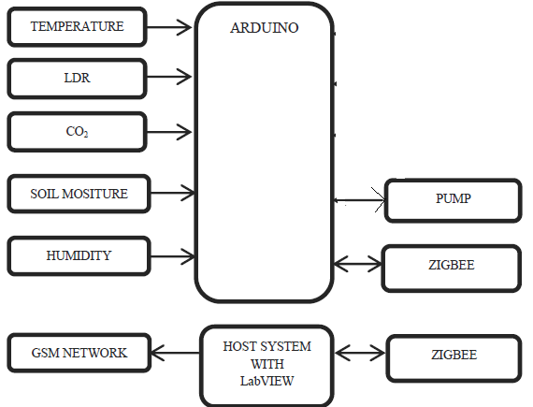

HARDWARE REQUIREMENT

* Arduino
* Temperature sensor
* Humidity sensor
* Co2 gas sensor
* Soil moisture
* Zigbee
* Pump
* LDR

SOFTWARE SYSTEM

* LabVIEW
* Arduino IDE